**Degrees of Freedom (DOF):** Min # of parms needed to fully specify config

**Displacement:** diff between initial and final location

**Distance:** Length of path traveled

**Speed** is just a scalar value where velocity has direction

Area under accel curve gives change in vel

Area under vel curve gives disp

The sum of mr2 for all the particles of mass in a solid is called the moment of inertia. Rod held on the end is (ML2)/3

**Parallel axis theorem:** Calculate MOI of body around axis: IP = Icm = Md2

The group of all rigid motions (*R*,*d*) is known as the **Special Euclidean group**, *SE*(3)

Axis angle forumulas

**Center of mass:** Point at which the three axes of rotation intersect

Parallel axis theorem for rotations: Io = RIRT

**Work:** Force applied to an object over disp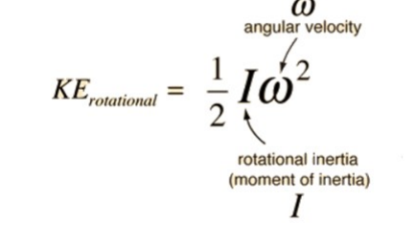

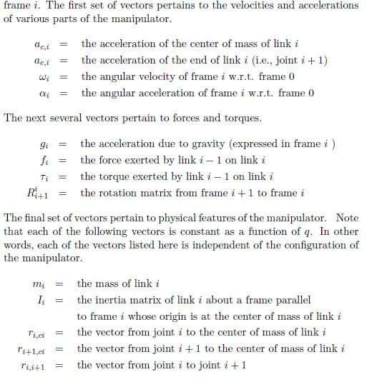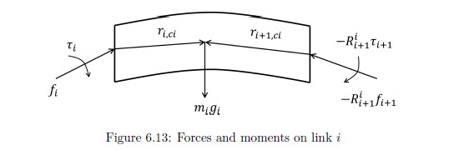

Start with the base case for a single link or the base of the robot

Newton's equation: calculate the net force and torque acting on the link

Euler's equation: computer the linear and angular acceleration of the link

Use the computed acceleration to update the linear

and angular velocity and the position for the link

Repeat the process for each link in the robot. Propagate the information from the base to the end effector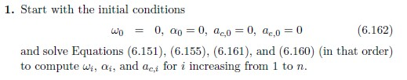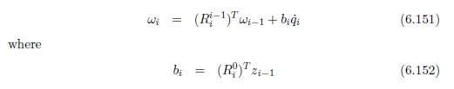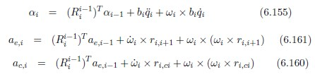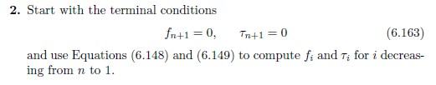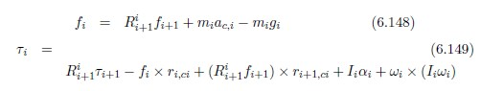Inverse Euler's equation: compute the joint torques required to produce the desired linear and angular acceleration for the current link

Inverse newton's equation: calculate the joint torques required to counteract the net force and torque acting on the link

Move up the robot's kinematic chain, calculating the joint torques for each link from the end effector down to the base

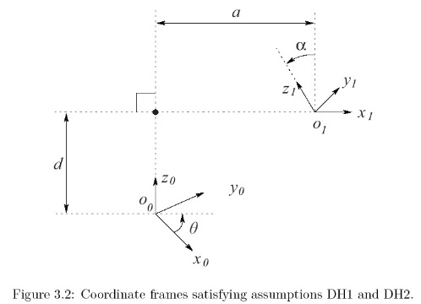Just PD controller can converge on steady state error and the integral portion helps fix that